**Theory of Continental Drift**

1. In your own words, describe the Theory of Continental Drift.

________________________________________________________________________________________________________________________________________________

1. What is the name of the super continent and when did it exist?

________________________________________________________________________

1. List the 5 types of evidence Wegener used to support his theory.

________________________________________________________________________________________________________________________________________________

1. What caused people to doubt Wegener’s theory?

________________________________________________________________________________________________________________________________________________________________________________________________________________________

1. Look at a world map. Apart from Africa and South America, describe and draw another example of regions that look as if they could fit closely together.

________________________________________________________________________________________________________________________________________________________________________________________________________________________

1. Identify three types of evidence for continental drift in the image below. Fill in the blank spaces.

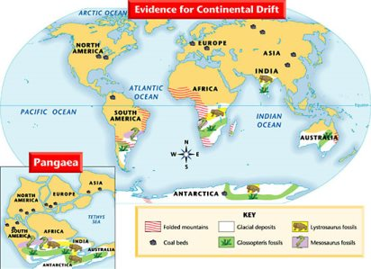

1. One piece of evidence in this image is _____________________________________.

This evidence shows that ________________________________________________ _________________________________________________________________________________________________________________________________________.

1. A second piece of evidence in this image is _________________________________.

This evidence shows that ________________________________________________ _________________________________________________________________________________________________________________________________________.

1. A third of evidence in this image is ________________________________________.

This evidence shows that ________________________________________________ _________________________________________________________________________________________________________________________________________.